CHAPTER 14: THE ATMOSPHERE

Checkpoint 14.1, p. 381
What proportion of Earth’s atmosphere is made up of carbon dioxide?
a) 18 percent
b) 7.3 percent
c) 0.55 percent
d) 0.038 percent

This is a content-level question since it is shown in Figure 14.3. The point is to make you immediately aware that the small relative amount of CO₂ in the atmosphere is very important to global temperatures.

Checkpoint 14.2, p. 382
When would oxygen have started to accumulate in the atmosphere if the early Earth had fewer landmasses?
a) Before 2.5 billion years ago
b) After 2.5 billion years ago
c) 2.5 billion years ago (no change)

Since primordial oxygen was consumed in weathering reactions with rocks, the fewer rocks (less land mass), the faster oxygen would have accumulated.

Checkpoint 14.5, p. 383
What is the difference between heat and temperature?
a) Heat deals with total kinetic energy, temperature with average kinetic energy.
b) Heat deals with average kinetic energy, temperature with total kinetic energy.
c) There is no difference, since they both deal with kinetic energy.

Checkpoint 14.6, p. 384
At approximately what temperature did Captain Joe Kittinger begin his descent upon exiting the balloon capsule?
a) 0 ºC b) -25 ºC c) -40 ºC d) -75 ºC

This is a comprehension-level question designed to have you read and interpret the graph in Figure 14.5.

Checkpoint 14.7, p. 384
At extremely low temperatures the thin polyethylene fabric (0.002 inches thick) that made up the balloon carrying Joe Kittinger’s capsule would have become nearly brittle. Any small flaws in the fabric could have caused the balloon to spring a leak and deflate. At what location during the ascent would the risk of this potential danger have been most acute?
a) Lower troposphere b) Upper troposphere c) Middle stratosphere
Checkpoint 14.13, p. 392
Your body feels cooler when you step out of a warm shower because
a) water evaporates on your skin.
b) water condenses on your skin.
c) water evaporates from the surrounding air.
d) water condenses in the surrounding air.

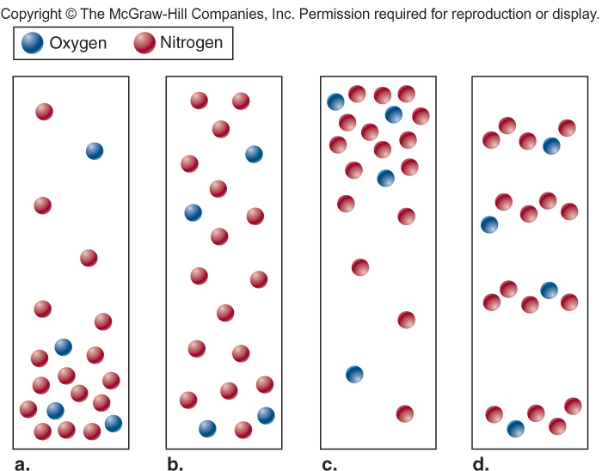

The correct answer is a.

Illustrates decreasing density with altitude.

Checkpoint 14.18, p. 395
In a few sentences, summarize the relationship between density, temperature, and pressure in a mass of air.

Good responses link the variables together while poor student responses list separate definitions for each.

Checkpoint 14.19, p. 396
An instructor asked her class to summarize some information about atmospheric processes. Students submitted the following four statements as part of their answers. The instructor returned the statements and told the students that they could correct them for full credit. Identify what is wrong with each statement, and describe how you would fix these answers to earn full credit.
1. The temperature of a rising parcel of air decreases by the normal lapse rate.
2. The percentage of oxygen in the atmosphere decreases with altitude.
3. When it rains, you have to use the wet adiabatic lapse rate to figure out temperatures at higher elevations.
4. The dry adiabatic lapse rate is higher than the wet adiabatic lapse rate so air temperatures should be higher in dry air (before condensation occurs) than in wet air (after condensation occurs).
- An actual parcel of air will decrease its temperature by the dry adiabatic lapse rate if it is unsaturated and the saturated lapse rate if saturated.
- The percentage of oxygen in the atmosphere does not change with altitude. The available number of molecules of all gases will decrease with altitude. Consequently, the density of the air decreases resulting in less available oxygen (# molecules/m³).
- Lapse rates deal with rising and falling parcels of air. But the term “wet” may convince some students that precipitation must be involved, rather than condensation.
- Since the lapse rate is higher, the temperature of the dry air is LOWER than it would be for saturated air. Temperatures will be higher in dry air as condensation will occur higher in the atmosphere where temperatures are lower.

Checkpoint 14.21, p. 399
Classify the clouds in each of the following images.

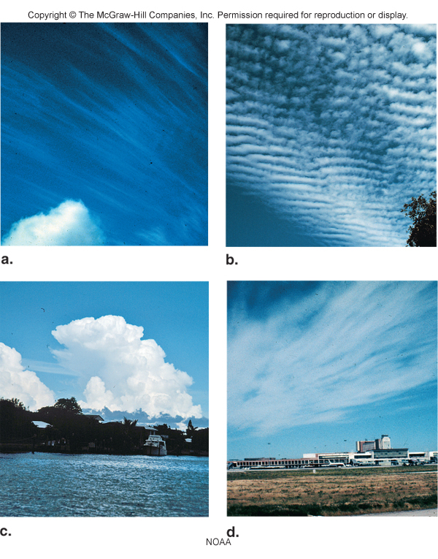

This is an application-level question. a) Cirrus, b) Altocumulus, c) Cumulonimbus,
d) Cirrostratus.
Checkpoint 14.22, p. 400
On July 2, 1982, truck driver Larry Walters decided to attach 45 helium-filled weather balloons to a lawn chair and go for a ride. Lawn Chair Larry rose to an altitude of nearly 5 km (16,000 feet). The high elevations and lack of oxygen made him dizzy, so he decided it was time to deploy his principal altitude control device, a pellet gun. He shot out several balloons and descended back to Earth. Which process was most significant in
Lawn Chair Larry’s balloon ride? Explain your reasoning.
a) Density Lifting b) Orographic Lifting c) Convergence Lifting d) Frontal Lifting

Larry rose into the atmosphere because of the lower density of the helium in the balloons. There is no indication that the other three mechanisms were operating here.

In the following landscape, how would the amount of rainfall change at location X if the mountain eroded down to the dashed line?
- Rainfall would increase.
- Rainfall would decrease.
- Rainfall would stay the same.

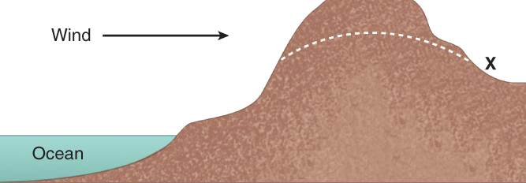

This is an application-level question regarding orographic lifting and the rain shadow effect. The existing mountain would force air to rise and to produce precipitation on the windward slope and produce a rain shadow effect on the leeward side of the mountain. If the elevation was reduced, there is a better chance that water would not be lost before the air arrived at X.

Checkpoint 14.23, p. 401
Use the information from the chapter to explain:
- Which air-lifting mechanism dominates where you live?
- Which states might provide examples of the four air-lifting mechanisms?
Open-ended question. The first portion of the response depends on where the student lives. Students should recognize that density lifting could occur anywhere and that western states from California through the Rockies are influenced by orographic lifting. Convergence and frontal lifting are more likely to dominate in Midwest to eastern states.

Checkpoint 14.24, p. 401
A parcel of warm air with an average temperature of 29ºC is present at sea level. The surrounding air has a temperature of 18.5 ºC. The parcel of warm air begins to rise due to density lifting. Assume that the relative humidity of the air mass steadily increases but never reaches 100 percent. Analyze how the temperature of the air mass would change as it rises, and determine at what elevation it would become stable.

Assuming a dry lapse rate of 10 ºC/km the air is at 19 ºC at 1 kilometer, 9 ºC at 2 kilometers, and -1 ºC at 3 kilometers. The surrounding air has a temperature of 12 ºC at 1 km and 5.5 ºC at 2 kilometers, and -1 ºC at 3 kilometers. The air will therefore stop rising at an altitude of 3 kilometers.

Checkpoint 14.25, p. 402
Find your state on the map in Figure 14.26. On the basis of the isobars, what direction is the wind blowing in your state?

Checkpoint 14.27, p. 404
- Draw an arrow to show the location and direction of the highest wind velocity on the following air pressure map, on the basis of the isobars alone.

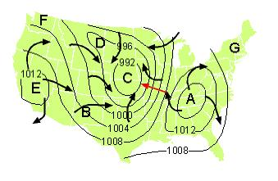
- Which point on the map is at the center of a low-pressure system?
a) A b) B c) C d) D e) E
- Rising air is present at which point?
a) A b) B c) C d) E e) G.
- If Earth did not rotate, wind would blow directly from _______.
a) A to C b) C to A c) C to B d) F to E e) B to E
- Draw arrows to fully illustrate the circulation patterns of winds on the map above when corrected for the Coriolis Effect (see finished map above).

You should draw clockwise rotations about the highs and counter-clockwise rotation about the lows.

CHAPTER 15: WEATHER SYSTEMS

Checkpoint 15.1, p. 412
Examine Figure 15.1. Find the closest major weather disaster near where you live. Explain if that type of event is the most typical weather that affects your life on a daily basis.

Relatively low-risk regions might include parts of the west (Arizona, Utah, Wyoming), the upper Midwest (Michigan, Wisconsin, Illinois), and the northeast (New York, Pennsylvania, New Hampshire, New Jersey). There are many potential high-risk states including Oklahoma, Texas (Great Plains), Florida, Alabama (southeast), and California (west coast). The patterns that they identify could include: hurricanes strike the Atlantic and Gulf coasts, tornadoes are present in Great Plains and Midwestern states, wildfires are more common in western states, heat waves occur more often in southeastern states (perhaps a counterintuitive discovery), and floods can happen almost anywhere. Students will learn why some states are more at risk than others and why some weather phenomena occur in specific locations as they read through the chapter.

Checkpoint 15.2, p. 413
Can you think of other earth science phenomena where it is necessary to assimilate data on a regional scale to accurately determine patterns?

(e.g. earthquake hazards, groundwater, floods).???

Checkpoint 15.3, p. 413
How are the following 4 key principals of science most evident in the brief history of meteorology discussed in this section?
a) Phenomena can be explained by natural causes.
b) Explanations are tentative.
c) Science is based on empirical observations.
d) Explanations should be testable.

The description of the history of meteorology has several examples of the use of empirical observations and the testing of explanations through the development of weather forecasting methods. The early Greeks did not ascribe many weather phenomena to natural causes and forecasting by its very nature is an example of the tentative nature of science due to the dynamic changes in weather patterns.

Checkpoint 15.4, p. 413
Go to the Weather Channel website (www.weather.com) and enter your city or zip code. Follow the directions at the site to obtain the 10-day forecast for your location.

Makes you some choose how to gauge the success of a long-term weather forecast. Good answers will recognize the tentative nature of forecasting and will allow forecast parameters to vary within a range rather than be simply right or wrong. Things a student might use to evaluate the success of the forecast could be the temperature, whether it rains or not, and if it is cloudy or sunny. Analysis of the actual weather over the next ten days should reveal that the weather diverges farther from the forecast over time.
Checkpoint 15.5, p. 414
Of the five most common types of air masses, which ones most directly affect the area where you live???

Checkpoint 15.7, p. 416
Thunderstorms and tornadoes are most frequently associated with weather patterns that form where maritime tropical air masses interact with continental polar air masses over the United States. Predict where this would happen most frequently using Figure 15.6.

Checkpoint 15.9, p. 418

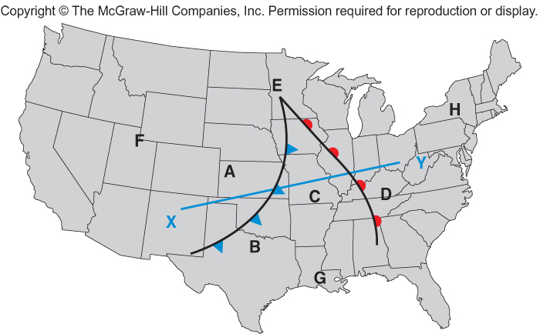

Use the map to answer the questions that follow.
X
- The map illustrates the relative positions of a warm and cold front. Where is the warm front located?
a) Between A and B b) Between C and D c) At E
- Where is it most likely to be raining?
a) A and B b) B and C c) C and D d) B and D
- Which location is in a maritime tropical air mass?
a) A b) G c) E d) H
- Which location will become warmer in the next 12 hours?
a) A b) B c) C d) D
- Which of the following images best represents conditions along the line X-Y on the map? Explain what is happening along X-Y for your choice.

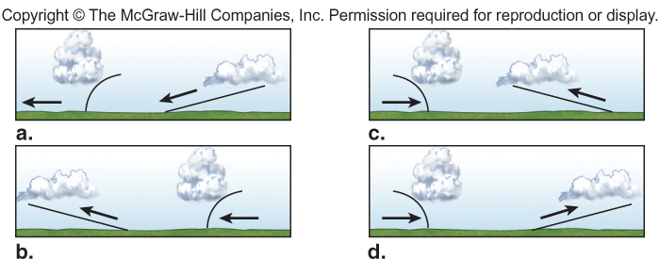
D: System is moving east with steep gradient at cold front.

Checkpoint 15.11, p. 420
Frontal Systems Changes
Weather conditions change with the passage of warm or cold fronts. These changes are related to changes in air pressure, air temperature, and in the state of water. Examine Figure 15.10 and answer the questions below.
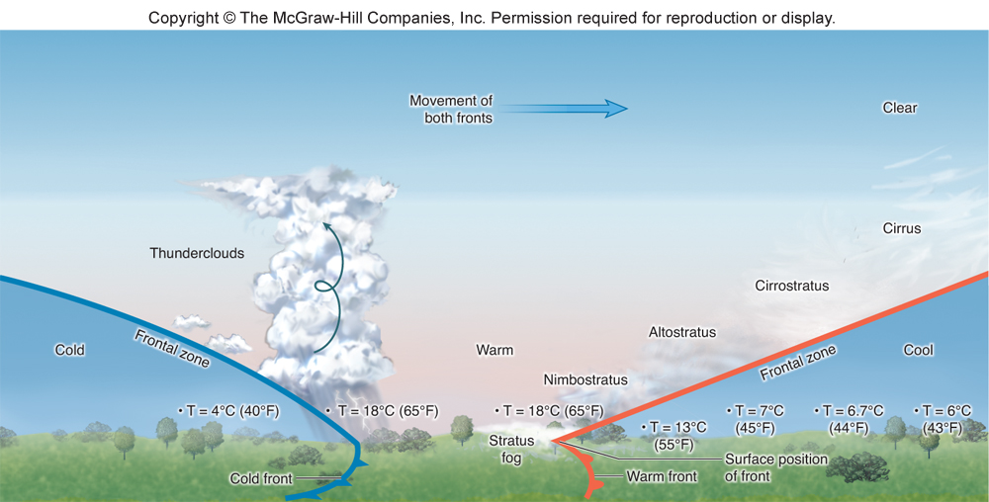

- Describe the change in state of water associated with the passage of a warm front.
As air rises along a gradual slope it eventually reaches saturation and produces rain. Some moisture remains in the air as it continues to rise, forming stratus and cirrus clouds.
- Will this change in state cause latent heat to be released or absorbed? Justify your answer.
Released. Water is condensing from water vapor to liquid water, thus releasing latent heat.
- Describe the adiabatic temperature changes associated with the passage of a warm front.
Temperatures on the ground would increase as the warmer air replaces the colder air. A parcel of warm air is forced up and over cold air causing the air pressure to decrease and the parcel to expand and cool at the dry adiabatic cooling rate. The warm air will have a relatively high moisture content causing condensation at relatively low levels and cloud formation. Subsequently, the rising air will continue to cool at the wet adiabatic rate

Checkpoint 15.13, p. 421
Which airport is most likely to experience flight delays due to thunderstorm activity?
    - Atlanta’s Hartsfield Airport, Georgia
    - Salt Lake City International Airport, Utah
    - Seattle-Tacoma Airport, Washington

Checkpoint 15.14, p. 422
Updrafts responsible for the formation of thunderstorm clouds are most likely to occur with which combination of conditions?
- Low-level warm, moist air; upper-level warm, moist air
- Low-level cool, dry air; upper-level warm moist air
- Low-level warm moist air; upper-level cool, dry air
- Low-level cool, dry air; upper-level cool dry air.

Checkpoint 15.16, p. 422
Rank the three thunderstorm components (air temperature, moisture, a lifting mechanism) in order of their significance in causing thunderstorms. Justify your ranking.

Moisture is the most important because changes of state of water drive thunderstorm development, without moisture thunderstorms don’t form. You can make a case for either temperature or a lifting mechanism as the second most important component. We would lean toward the lifting mechanism as the next most important as it begins the process that causes air to rise. The temperature is also important as it determines the saturation level. but it becomes more significant in rising, expanding, cooling air.

Checkpoint 15.17, p. 424
Given what you have already learned in this chapter, predict which listing below shows the correct rank order for states with the greatest number of tornadoes in March, June, and August.
a) Florida, Oklahoma, Minnesota
b) Oklahoma, Florida, Minnesota
c) Minnesota, Oklahoma, Florida
You should recognize that the collision between cP and mT air masses migrates northward from spring to summer.

Checkpoint 15.18, p. 424
Examine the image of tornado damage. Rank the damage using the Fujita intensity scale.
a) F1 b) F2 c) F3 d) F4

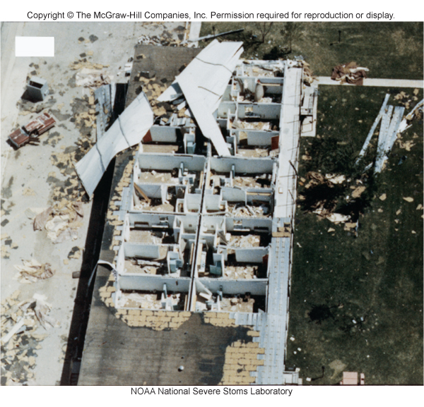
This is likely F2 damage because there is substantial devastation but the walls are still standing.

Checkpoint 15.20, p. 426
Explain why the number of tornadoes counted each year has increased, while the number of days with at least one tornado sighting has remained essentially unchanged for several decades.

The number of tornadoes reported has increased because the technology used to identify tornadoes has improved. The number of days with tornado sightings has not changed because the weather patterns that give rise to tornadoes have remained unchanged.

