Geologic Resources of Iowa 20 points
Homework #1 – History and Importance of Geology in Iowa

1. To the extent of your current knowledge describe the geology of your county as specifically as you can… (4 pts) Try to be as specific as you can, but don’t stress about finding out every detail… Just trying to learn where you are in the geologic knowledge of your specific area. (About a paragraph)
2. Of the nine BIG IDEAS in Earth Science Literacy, which two make the most sense to you/why AND which two are the most difficult to understand and/or teach, why? (4 pts) Here is a link for the Big Ideas https://scied.ucar.edu/sites/default/files/images/long-content-page/earth_science_literacy_brochure.pdf
3. Using the www.understandingscience.org website, click on the For Teachers tab >Click on your grade section in the Teachers lounge (e.g. K-2, 3-5, etc. ) > Under Getting Started, click on Tips for teachers and read this section… In general how interested are your students in science, do you think these tips are useful, would they help your student understand science? (2)

Week 1 Part 2 - Geologic History, Concept and Tools

1. Pick one of the historical figures/founders of geologic knowledge that we talked about, who do you find the most, scientifically or personally, interesting, go beyond my basic intro with some (library or internet) research and let me know what you discovered by writing a short summary of your findings (1 page max.) (5 pts)

2. Using the relative dating principles discussed this week, try to figure out the correct order, oldest to youngest, of the geologic events? *If you are just getting started with geology let me know, the use material in session one and give it your best shot. If you have had a lot of geology classes and want a challenges, try to write short geologic history for the block diagram in addition to relatively dating it… (5 pts)
If you are trying the challenge part of this question here is a –

Key To The Rock Units
A = gabbro, B = siltstone, C = basalt, D = basalt, E = gabbro, F = till, G = sandstone, H = fault, J = Limestone, K = shale, L = greywacke, M = sandstone

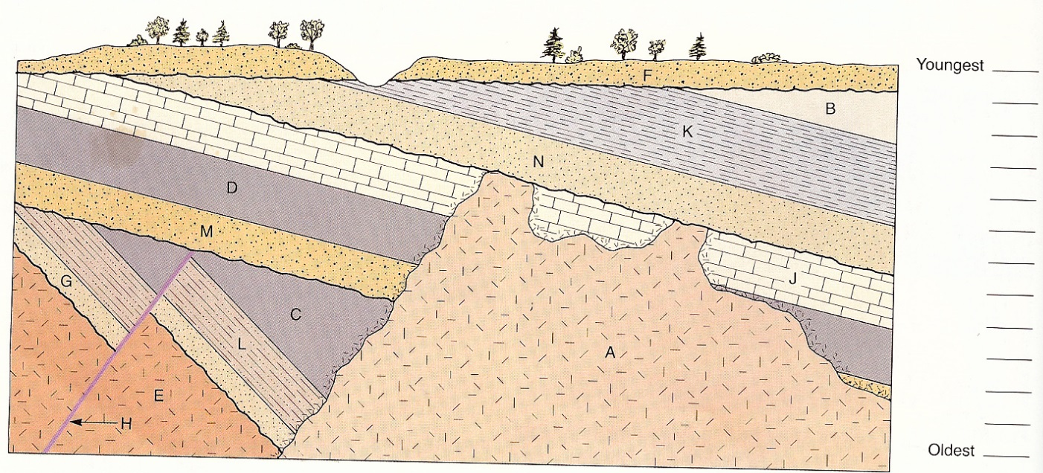PLEASE do not get stressed out by these, especially if you are just getting started in geology! If you get stuck feel free to use more resources than our presentation (although the answers are in there)… Don’t have access to geologic knowledge or time, send a question or two via e-mail and I will help you out ! - Chad
_____ 1. Which geologic time period makes up 88% of the Earth’s 4.6 Ga.
- Cenozoic B. Mesozoic C. Paleozoic D. Precambrian

_____ 2. Who applied geochemistry (U/Pb isotopic decay) to the Earth’s crust revealing it absolute age.
- Cornelia Cameron B. Nicolaus Steno
C. James Hutton D. Clair Paterson

_____ 3. The Earth’s inner and outer core that contain remnant energy from the Big Bang (Earth’s origin) is enriched in what element?
- Silicon (Si) B. Iron (Fe) C. Oxygen (O) D. Carbon (C)

______4. Oceanic crust...
A. is more thick than continental crust C. is more dense than continental crust
B. contains more silicon minerals than continental crust D. all of the above

_____ 5. This underground geologic feature runs from north east Kansas to Lake Superior and around to the upper peninsula of Michigan. This feature contains dark, dense rock potentially containing abundant minerals. This feature is called?
- Olduvai gorge C. Mid-Atlantic Spreading Ridge
- Mid-Continent Rift D. Des Moines Lobe

